Using Tomcat 8.5.42 to run Lab6.

To Start Tomcat (Download Tomcat 8.5.42 and put it on the desktop):

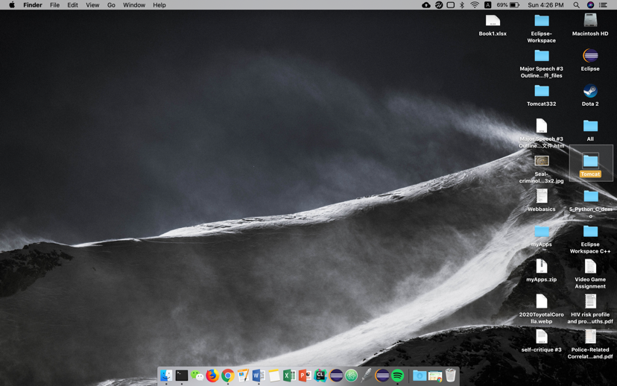

Double click the Tomcat Folder and then go in the webapps folder.

There is a folder MyLab where I stored my Lab6 in:

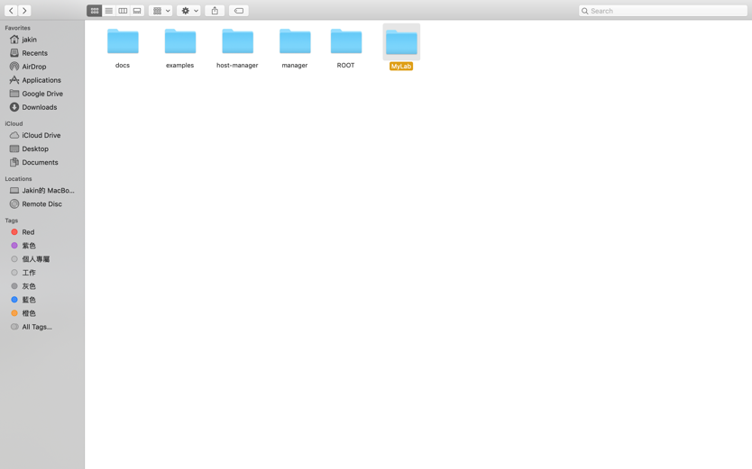

Inside MyLab there are some txtfiles for reading in the automobiles, some pictures for the web browser and two files src and WEB-INF. Src is where I keep all my java files for Lab6: 3 java servlets and 1 jsp, and all the other java files we did for the previous labs. WEB-INF is where I store my .class files and my web.xml.

Linking Classpath, compile and run tomcat:

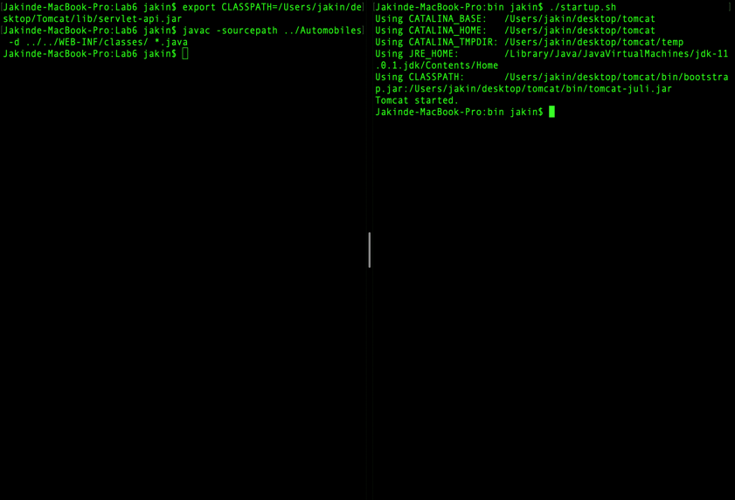

Running Tomcat on the browser:

1st servlet (Choose the car you want to configure):

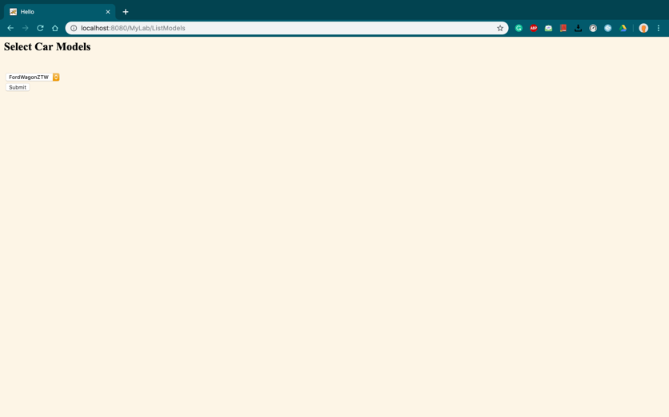

2nd servlet (Configure you car):

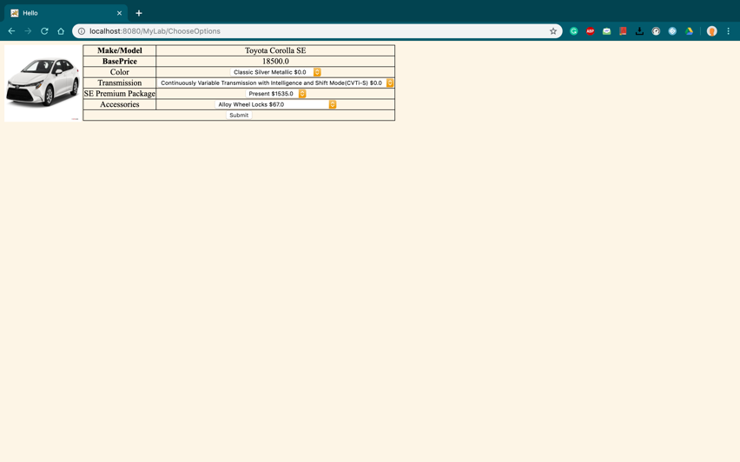

3rd servlet (Showing the user the result they have configured, you can generate a excel file containing your result):

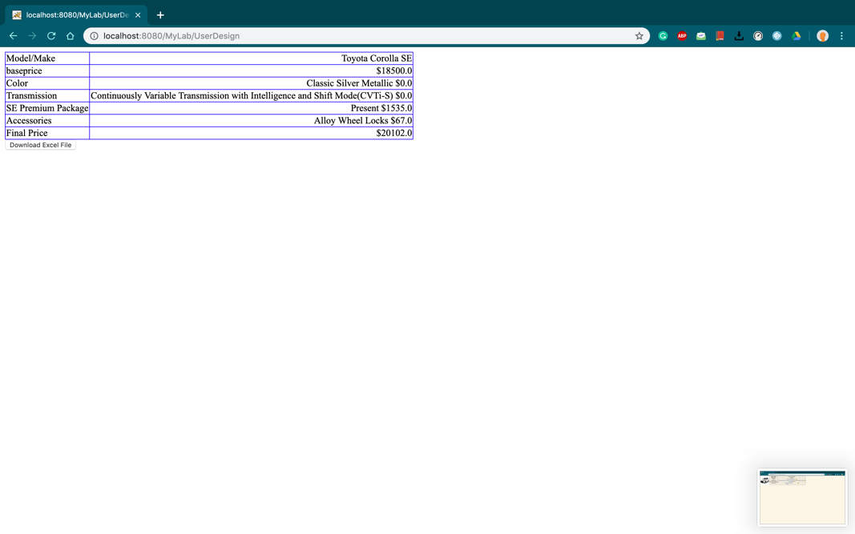

The jsp(generate the excel file):

